Geography Questions
- Name and describe 3 jobs in geography you are interested in and the average salary they make.
- Geographic Information Systems Technician: This job involves the making, reading and interpretation of maps. It also involves manipulation and management of land data that exists in the geographic information system (GIS) database. The average salary for this job is $65,470 (AAG, 2019).
- Climate Change Analyst: This job involves monitoring of the current climate to predict what climatic conditions to be expected in the future. It also involves study evaluation of current and past data on climate to help in the creation predictions and models of what the earth’s climate would be like in the future. The average salary for this job is $71,360 (AAG, 2019).
- Environmental Restoration Planner: People in this job conduct investigations and analyses to determine how pollution occurs and its sources. They then develop ways and perform cost assessments on how the polluted areas of the environment can be cleaned and restored. The average salary for a person on this job is $71,360 (AAG, 2019).
- What are the three broad categories of geographic analyses, and why do geographers favor their integration to most effectively study and understand systems?
The three broad categories of geographic analysis are the analysis of the physical systems of the earth, study of cultural landscapes, people and the cultures on earth, and the analysis of political economies in the various parts of the world (Smith & Mark, 2001). Geographers favor the integration of these categories into the study of geographical systems as they help in providing information on how the world is connected and how the regions, people and cultures on earth affect each other and the effect that they have on the earth’s geographical changes and outlook.
- What European countries originally dominated the United States during the colonial era, and what are some of the impacts of each of these colonial empires on the political systems and cultures of the U.S. today?
The European countries that originally dominated the United States during the colonial period are Spain in 1565, Britain in 1587, France in 1608, and the Netherlands in 1609 (Sauer, 2020). Colonization led to the increase in the number of people from the colonizing countries migrating to the United States. This affected the native culture greatly as the invaders introduced new language dialects, types of food, sports, arts, modes of dressing, music, social habits and sports. The American culture therefore became a mixture of various cultures. Colonization also led to the creation of cultural regions; each dominating the areas where the various European dominators had first settled (Horne, 2018). The U.S. political system was greatly affected by British colonization. The colonies established by the British in the Eastern part of North America provided a basis for the evolvement of the current form of government. The use of courts, the bill of rights, elections and use of governors as head of states are examples of political influences of the British to American politics (Neil, 1871).
- Name at least one North American example of a functional and a formal region. Then sketch each of your regions on a map of North America. Label each region you have informally drawn on your map as either functional or formal
Functional region: Atlanta
Formal region: North East Region
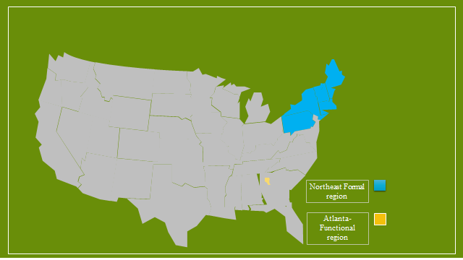Map template from slideegg.com
- This text is primarily a “regional geography” book because the majority of chapters in it cover the geographies of a specific region of North America. Only three of the chapters in the book focus on “thematic geography” instead of on regional geography. List the titles of these three chapters and make an argument that they are, indeed, more thematic than regional in scope by browsing the outline of the contents of each one
- Chapter 2: North America’s Environmental Setting
This chapter focuses on North America’s landforms, hydrology, soils, physiographic provinces, weather, climate, biogeography, ecology, watersheds and ecosystems in general (Hardwick et al., 2013).
- Chapter 4: North American Political Economy
This chapter focuses on North America’s contemporary economy, changing urban systems, comparison to world economy, and political institutions (Hardwick et al., 2013).
- Chapter 19: The Future of North America
This chapter focuses on the environmental issues in the past and in the 21st century. It also looks at North America’s Demography and Population Patterns, Culture, Race, and Ethnicity, Economy, Urbanization, and Shifting Urban Growth Patterns. Finally, it covers the role of North America in the world and looks at North America in the 21st century (Hardwick et al., 2013).
These chapters are thematic because they do not focus on the geography of any specific region in North America but rather looks at the socio-political, physical and economic factors and how they affect North America as a whole.

References
AAG. (2019). About Geography Careers Overview. AAG. Retrieved from: http://www.aag.org/cs/careers
Hardwick, S. W., Shelley, F. M., & Holtgrieve, D. G. (2013). The Geography of North America: Environment, Culture, Economy. 2ed. Pearson Higher Education.
Horne, G. (2018). The apocalypse of settler colonialism: The roots of slavery, white supremacy, and capitalism in 17th century North America and the Caribbean. New York University Press.
Neill, E. D. (1871). The English colonization of America during the seventeenth century. London: Strahan.
Sauer, C. O. (2020). Sixteenth Century North America. University of California Press.
SlideEgg (2020). Free Editable U.S. Map with States. Retrieved from: https://www.slideegg.com/free-editable-us-map-with-states
Smith, B., & Mark, D. M. (2001). Geographical categories: an ontological investigation. International journal of geographical information science, 15(7), 591-612.

